269-[DF]-Lab - Insert, Update, and Delete Data in a Database
The database operations team has created a relational database called world containing three tables: city, country, and countrylanguage. You have to validate the configuration of the database by running INSERT, UPDATE, and DELETE statements on the country table.

Task 1: Connect to a database
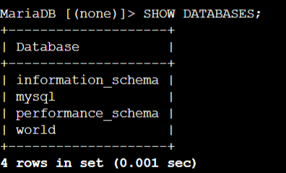
Task 2: Insert data into a table
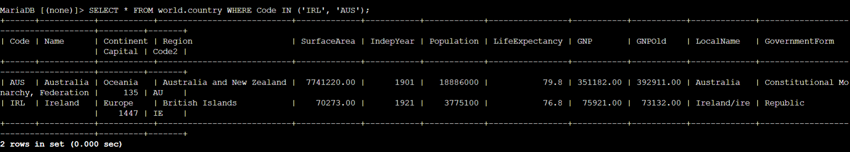
Task 3: Update rows in a table
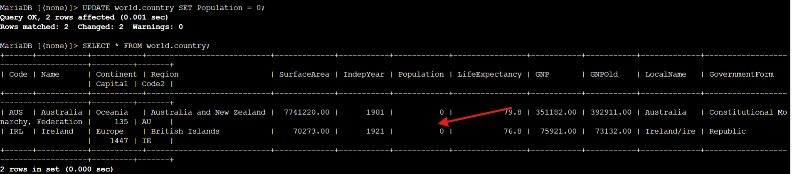
To update the Population and SurfaceArea columns for all rows in the country table
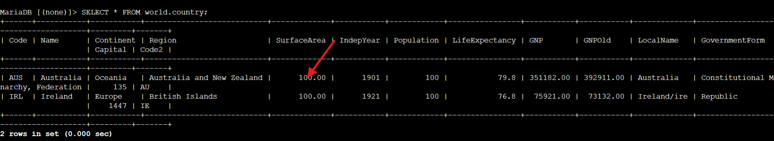
Task 4: Delete rows from a table
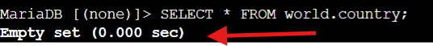

Task 5: Import data using an SQL file
Notice that there are more entries in the country table.
